
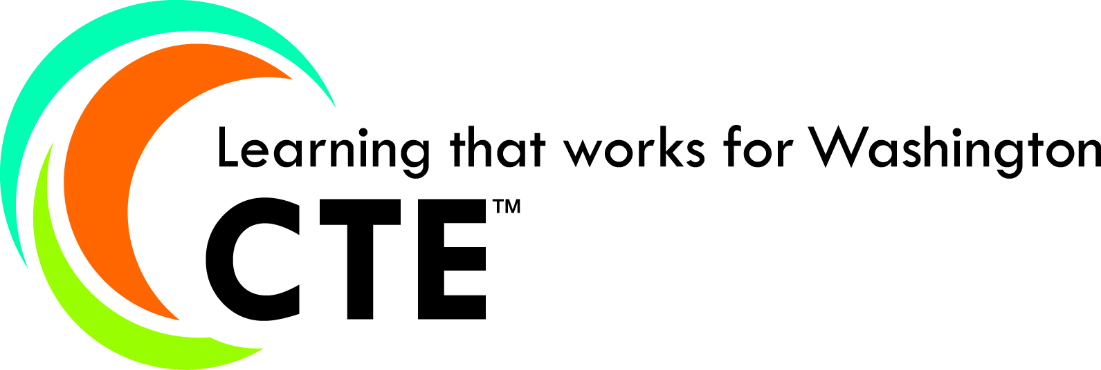
Updated 1.2017

Blank Framework Template
Course: Name of Course |  | Total Framework Hours:
CIP Code: | Exploratory Preparatory | Date Last Modified:
Career Cluster: |  | Cluster Pathway:

To duplicate this blank table (for additional units), select the table, select copy, place cursor below the first table, and select paste.
COMPONENTS AND ASSESSMENTS
Performance Assessments:
Leadership Alignment: Leadership activity embedded in curriculum and instruction. This includes the leadership skills that are being taught and assessed within the class for all students – and should be tied to 21st Century Skills, and should be specific to the unit of instruction. The event/activity/or project and the associated 21st Century Skill should be clearly articulated.
Example: Students will demonstrate the ability to communicate clearly through their group project presentation.
Or – Safely Research Project – Analyze Media
CTSO activities may be appropriate if all students, within the course, are taking part in the specific event.
Standards and Competencies
Unit:

Industry Standards and/or Competencies |  | Total Learning Hours for Unit:
•
•

Aligned Washington State Learning Standards
Arts
Computer Science
Educational Technology
English Language Arts
Environment & Sustainability
Financial Education
Health and Physical Education
Mathematics
Science
Social Studies

The 21st Century Skills should be taught and assessed throughout the course.This table should be included at the end of this document.
21st Century Skills
Check those that students will demonstrate in this course:
LEARNING & INNOVATION  Creativity and Innovation  Think Creatively  Work Creatively with Others  Implement Innovations  Critical Thinking and Problem Solving  Reason Effectively  Use Systems Thinking  Make Judgments and Decisions  Solve Problems  Communication and Collaboration  Communicate Clearly  Collaborate with Others | INFORMATION, MEDIA & TECHNOLOGY SKILLS  Information Literacy  Access and /evaluate Information  Use and Manage Information  Media Literacy  Analyze Media  Create Media Products  Information, Communications and Technology  (ICT Literacy)  Apply Technology Effectively | LIFE & CAREER SKILLS  Flexibility and Adaptability  Adapt to Change  Be Flexible  Initiative and Self-Direction  Manage Goals and Time  Work Independently  Be Self-Directed Learners  Social and Cross-Cultural  Interact Effectively with Others  Work Effectively in Diverse Teams  Productivity and Accountability  Manage Projects  Produce Results  Leadership and Responsibility  Guide and Lead Others  Be Responsible to Others

